**Ideation Phase**

**Brainstorm & Idea Prioritization Template**

|  |  |
| --- | --- |
| Date | 16 September 2022 |
| Team ID | PNT2022TMID15255 |
| Project Name | Retail Store Stock Inventory Analytics |
| Maximum Marks | 4 Marks |

**Brainstorm & Idea Prioritization:**

**Step-1: Team Gathering, Collaboration and Select the Problem Statement**

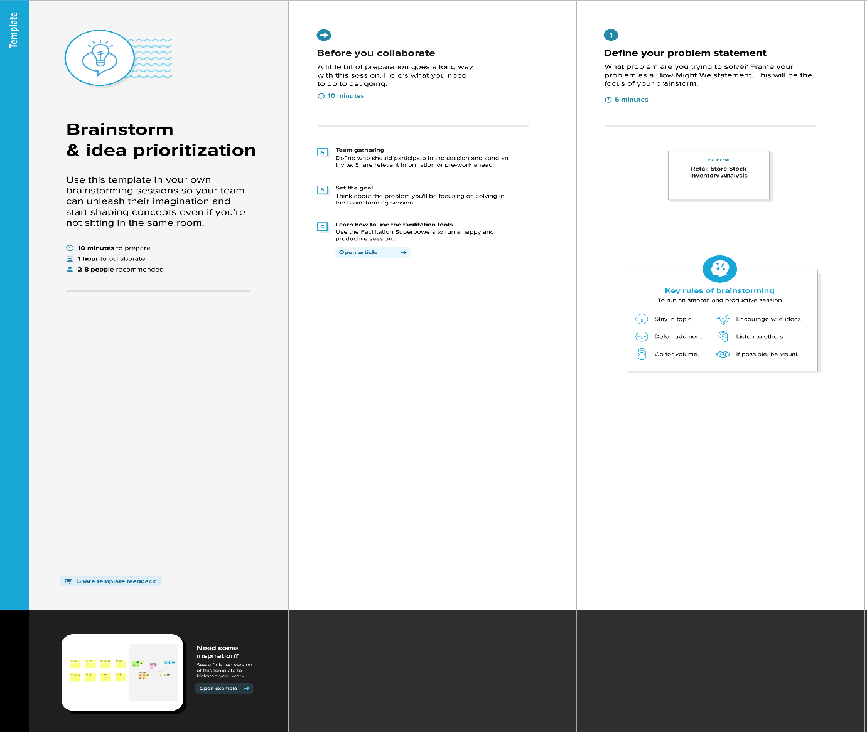

**Step-2: Brainstorm, Idea Listing and Grouping**

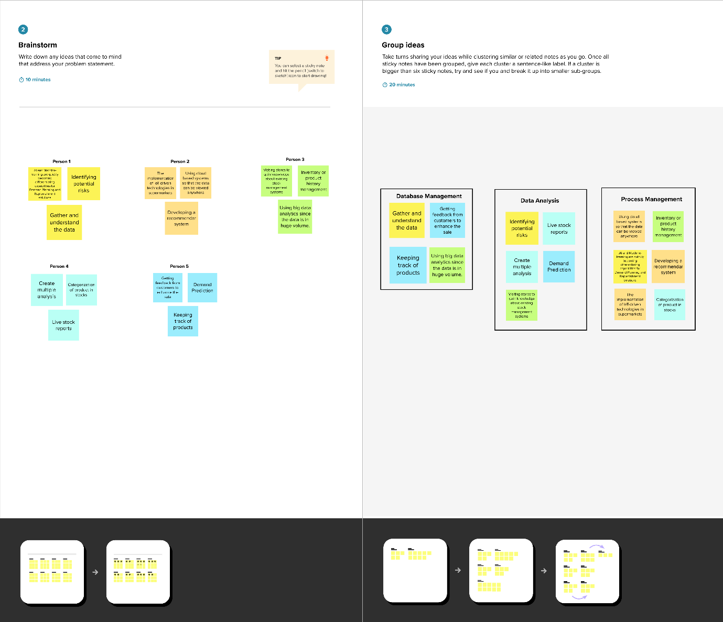

**Step-3: Idea Prioritization**

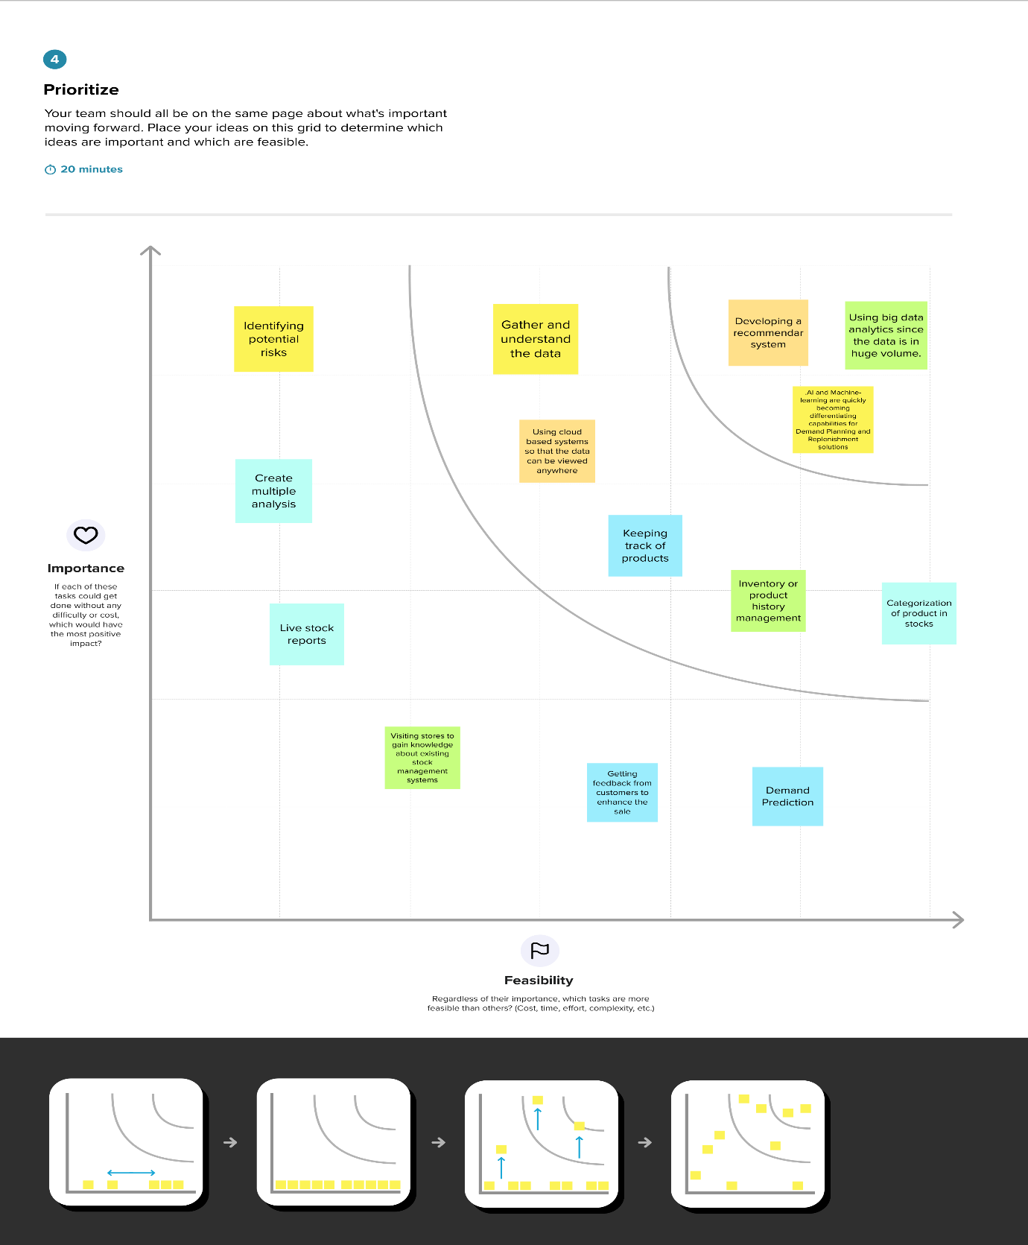

<https://app.mural.co/invitation/mural/shalini8859/1664175494284?sender=u80be3b6c8f90b1ee7d026646&key=e39c6b46-bd95-4c8e-a22f-c37a06a88f0d>